Families Registering for Events
Before You Start
Review any registration information provided by your County Extension Office or the State 4-H Office about the event for which you intend to register.
Steps  - Log in to your family’s 4-H Online account.  - Click the Register button below the event name on the Member List page  OR  Click on Events in the navigation pane, and then click Register for the event. | Screenshots  (Screen appearance may vary per state)  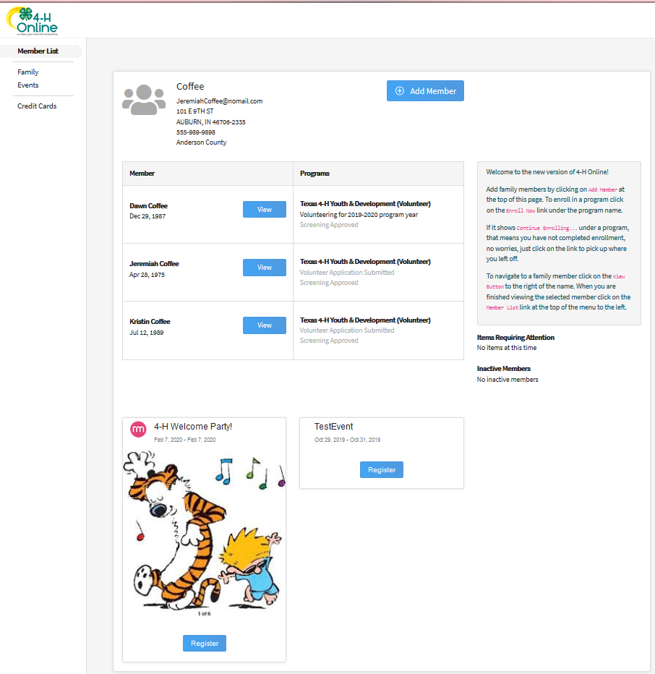
- Click the Member’s name that you would like to register for the event.  - Click the Select button. | 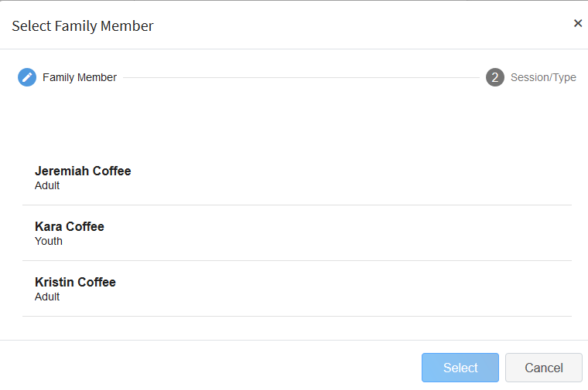
- Click on the Session/Type name for which they are registering. In some events, the member may qualify for more than one Session/Type.  - Click the Start Registration button. | 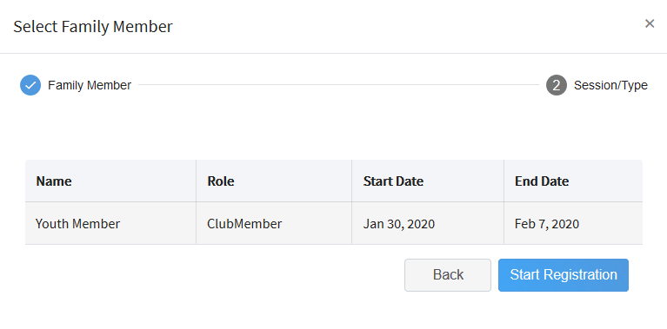
- Complete each question.  - If a file upload is needed, click the upload button. Navigate your device and select the file to upload.  - Click the Next button once the questions and file upload (if applicable) are complete. | 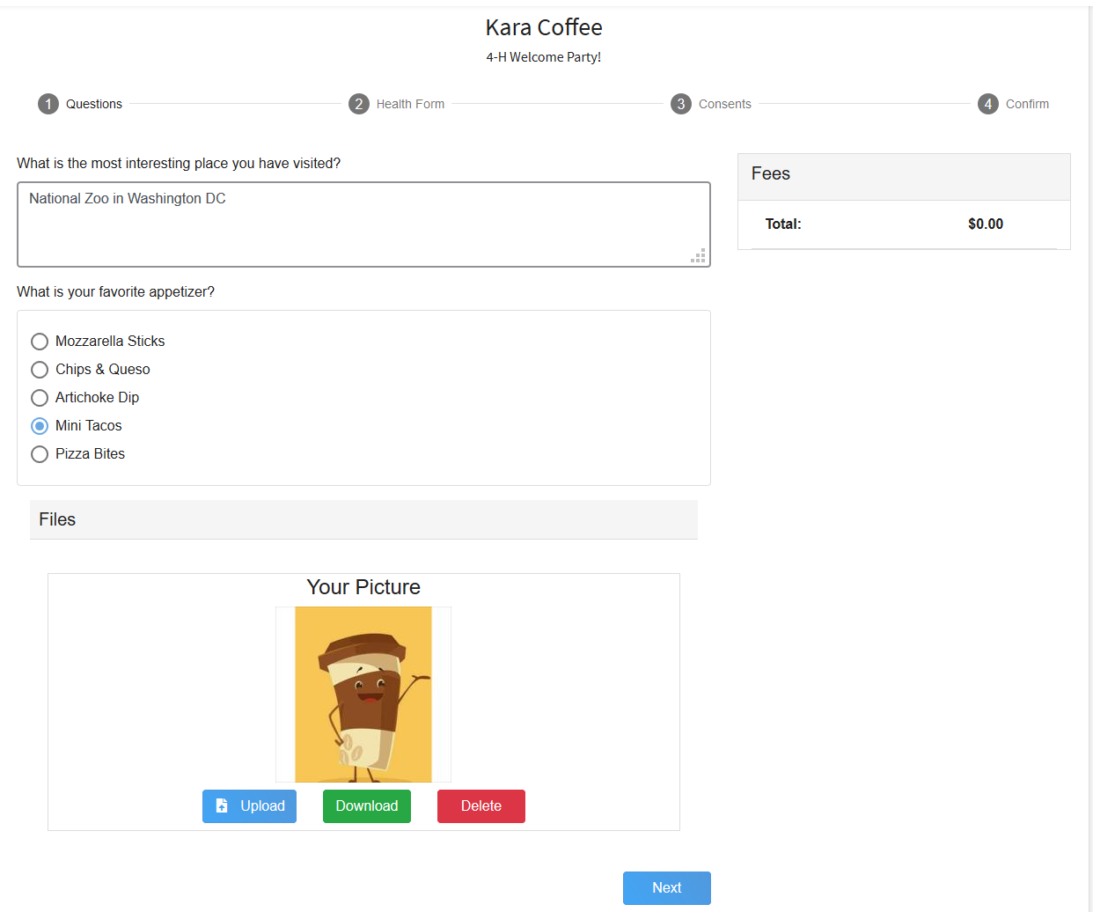
- If applicable, review the Health Form information and make changes if needed.  - Complete the Medical Release.  - Click the Next Button. | 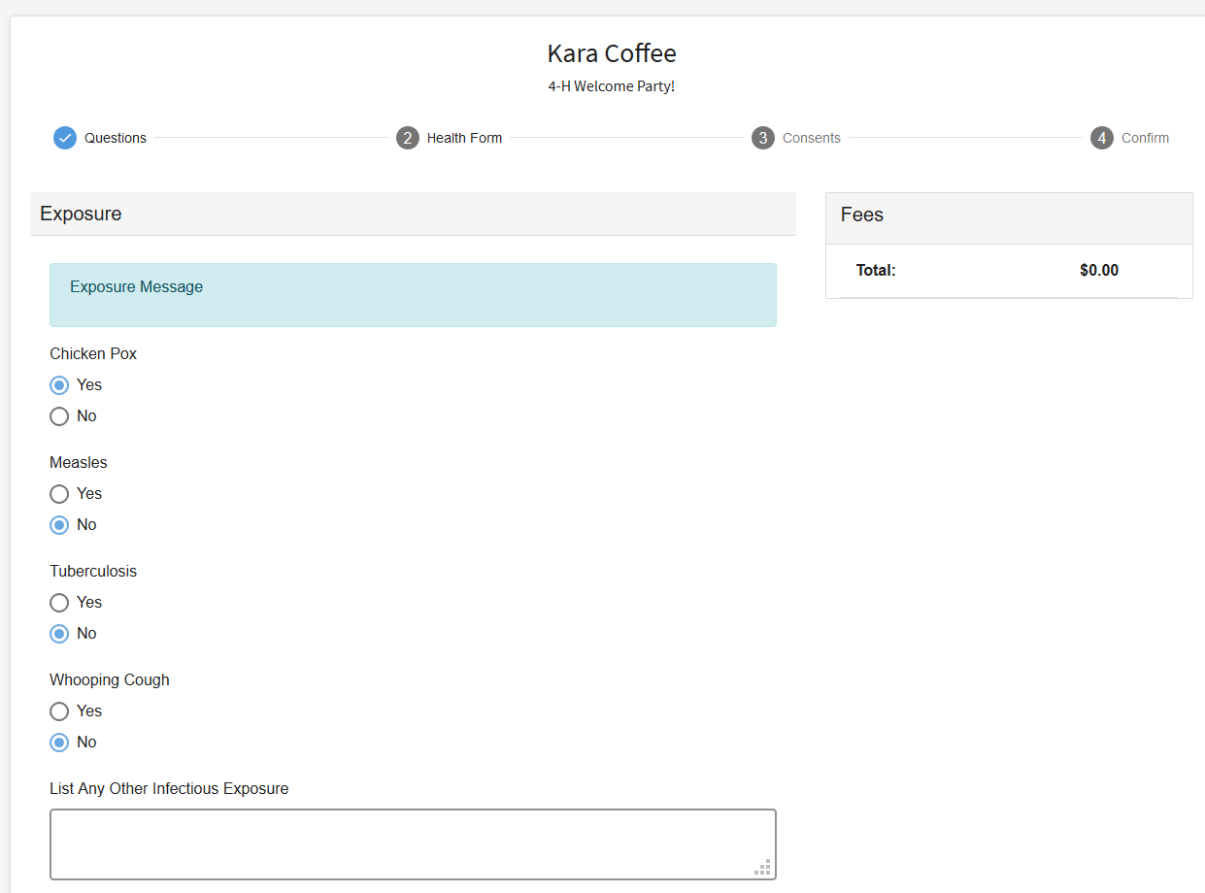  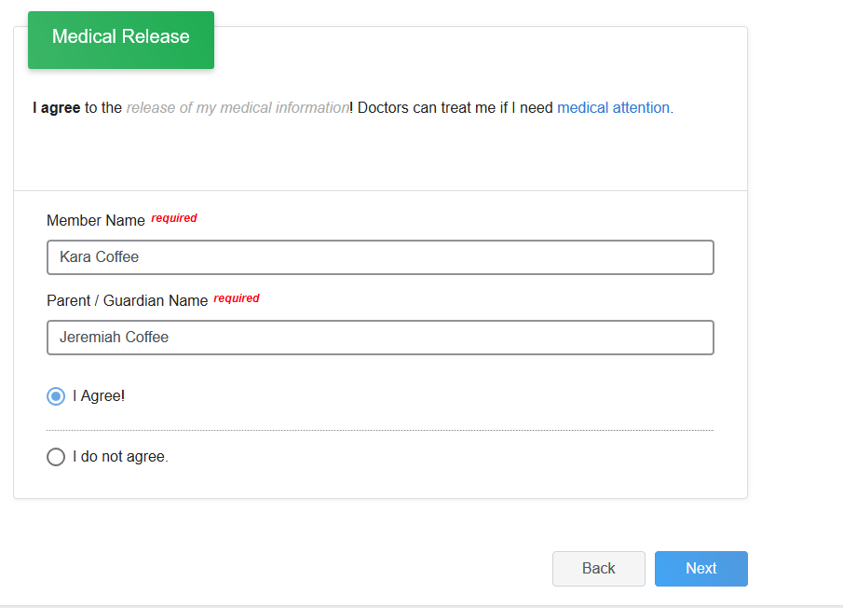
- If applicable, complete the required consents.  - Click the Next button. | 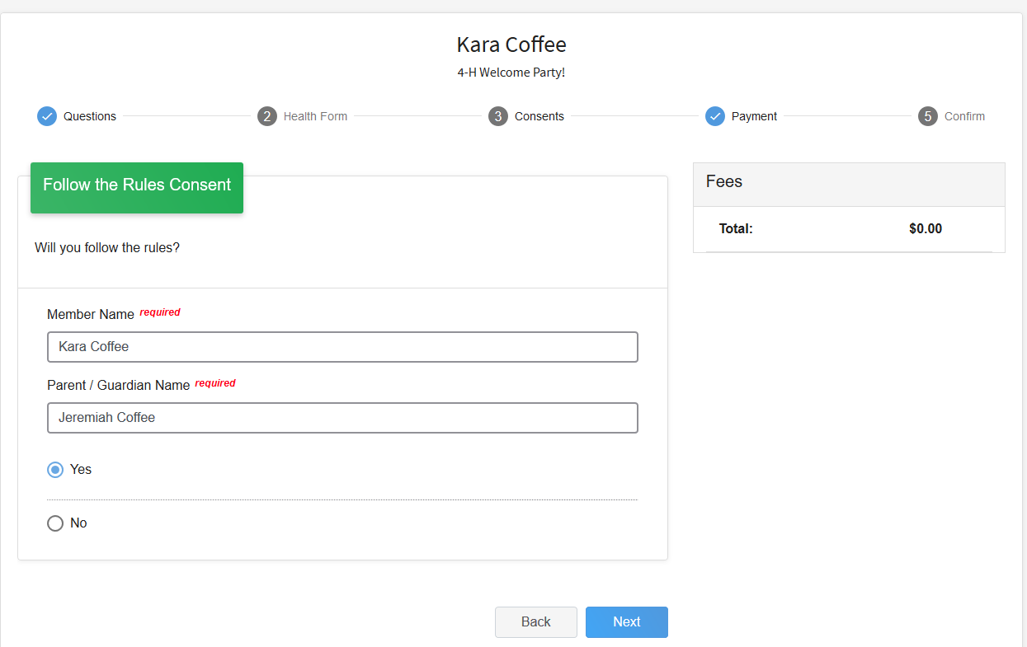
- If applicable, select the payment method to pay any fees that are associated with the registration.  - Click the Finish button.  - Your event registration has been submitted. You should receive an email indicating that the registration has been submitted. You will receive an additional email when it has been reviewed and approved and when the payment, if any, has been processed. | 